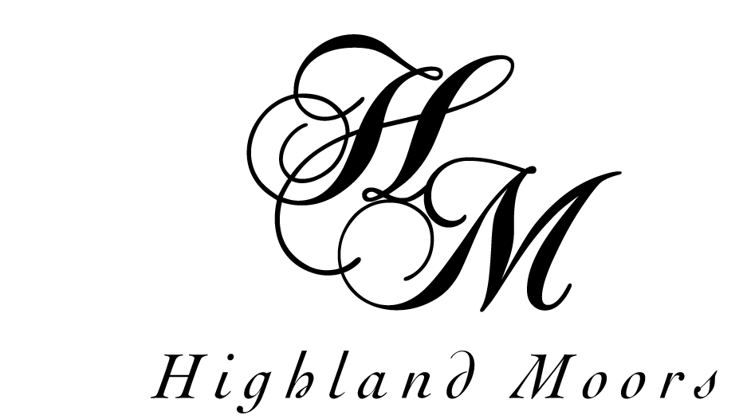
Conference and Meeting Reservation & Confirmation Form 2017
Name:
Company:
Address:
Tel:
Email:
Event / Activity:
Date(s) required:
Time: From: To: Nos. attending:
Room Name:
Room layout:
Agreed room hire charge:
Equipment: Please tick
WIFI and white screen free of charge
Flip chart: £7: Projector: £18 Laptop: £15

Catering:
Tea, coffee, biscuits & water £2.15 per person Yes/No Time(s):

Food requirement:
A Sandwich platter lunch @£8.95 pp
B Finger buffet @£10.95
C None
Other requirements:
Payment:
Would you like to settle your account by cheque/credit card Yes/No
Account to be invoiced Yes/No
Contact Name: As above
Address:
Email:
Tel:
Purchase Order No.: ___________________
Have you used our facilities before ? Yes/No
If no, how did you hear about Highland Moors ?

Booking & cancellation terms
Please return this form to Highland Moors as soon as possible after booking. Final numbers attending should be notified one week before the date reserved or as soon as possible if booking is made within one week period. Payment in 30 days from invoice date please. Written cancellation must be received at Highland Moors 2 weeks prior to the date. Rooms cancelled within 2 weeks will be subject to 50% of the room hire fee. Rooms cancelled within 48 hours will be subject to full room hire and catering costs.

Please email or return this form to: sue@highlandmoors.co.uk or
Highland Moors, Wellington Road, Llandrindod Wells, Powys, LD1 5ND
Signature of Organiser: ______________________ Date: ________________

